Binary Choice models. Multiple Choice tests for Classes 14-15.

- Linear probability model (p_{i} = p(Y_{i} = 1) = β₁ + β₂X_{i ,} or Y_{i} = β₁ + β₂X_{i} + u_{i}) has the following property
- the expected value of the disturbance term u_{i} is not equal to zero;
- the distribution of the disturbance term is neither normal, nor continuous;
- marginal effect of the explanatory variable X differs with X;
- the calculated probability is always within the closed interval [0;1];
- the OLS method does not give any estimators of the parameters (β₁;β₂).

- Linear probability model (p_{i} = p(Y_{i} = 1) = β₁ + β₂X_{i ,} or Y_{i} = β₁ + β₂X_{i} + u_{i}) does not have the following property
  - marginal effect of the explanatory variable X is the same in all its range;
  - the calculated probability value may get outside the closed interval [0;1];
  - it is impossible to estimate its parameters using Maximum Likelihood method;
  - the disturbance term u_{i} is heteroscedastic;
  - the disturbance term u_{i} has only two possible values for given X_{i}: (1 – β₁ – β₂X_{i}) and (–β₁ – β₂X_{i}).

3. In the logit model the probability that the binary dependent variable Y equals to one is:
1) 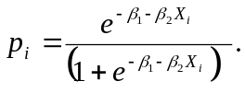 2) 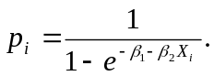 3) 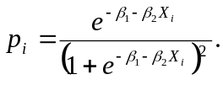
4) 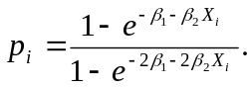 5) none of the above.

4. In the probit model the probability that the binary dependent variable Y equals to one, depending on X_{i}, is:
1) p_{i} = p(Y_{i} = 1) = β₁ + β₂X_{i}. 2) 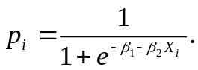 3) 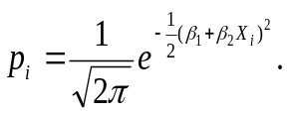 4) 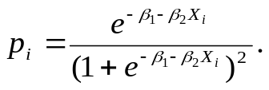 5) none of the above.

5. The functions (a)-(e) are under consideration:
a) 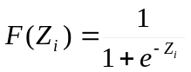; b) 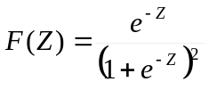; c) 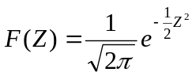
d) 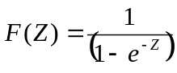 ; e) 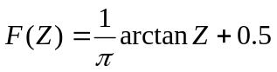
The following functions among (a)-(e) are not sigmoid (S-shaped) functions of Z appropriate for modeling probability:
1) (a) and (e) functions only; 2) (b), (c), (d) and (e) functions only;
3) (b), (d) and (e) functions only 4) (b), (c) and (d) functions only;
5) (a), (c) and (d) functions only;

6. Logit-estimation of the model F(Z_{i})=p(Degree_{i}=1| ASVABC_{i},β) has given the result
Z=-11.96+0.169·ASVABC. The probability of getting academic degree (Degree=1) under ASVABC=60 is equal:
- 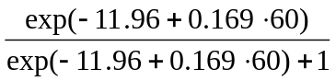; 2) 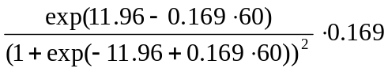;
3)()·0.169; 4) 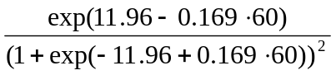;
5) 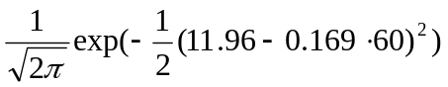.

7. Probit-estimation of the model F(Z_{i})=p(Degree_{i}=1| ASVABC_{i},β) has given the result
Z=-5.787+0.0782·ASVABC. Increase of the probability p(Degree_{i}=1) under one point increase of ASVABC, for ASVABC=60 equals:

- ; 2) 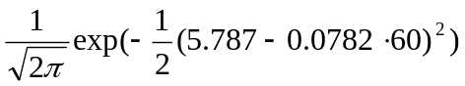;
3)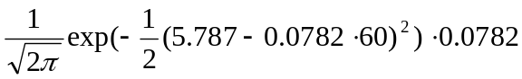;
4) F(-5.787+0.0782·60), where F is the function of standard normal distribution;

5) F(-5.787+0.0782·60)·0.0782, where F is the function of standard normal distribution.

8. Let multiple linear regression model Y_{i} = β₁ + β₂X_{2i} +…+β_{k}X_{ki} +u_{i}. be estimated by Maximum Likelihood method.
The Likelihood Ratio statistic LR is distributed as a chi-squared statistic under the following null hypothesis H₀, is calculated by the following formula, and with the following number of degrees of freedom:
1) H₀: β₂=β₃=…=β_{k} =0; LR=1 – 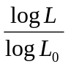; with k – 1 degrees of freedom
2) H₀: β₁=β₂=…=β_{k} =0; LR=2 log 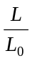 ; with k – 1 degrees of freedom
3) H₀: β₂=β₃=…=β_{k} =0; LR=2 log ; with k degrees of freedom
4) H₀: β₂=β₃=…=β_{k}; LR=2 log ; with k – 1 degrees of freedom
5) H₀: β₂=β₃=…=β_{k} =0; LR=2 log ; with k – 1 degrees of freedom

